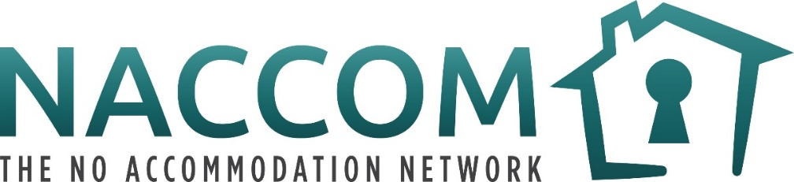

Community Researchers – volunteer role description
“As refugees and people seeking asylum in the UK we think we shouldn’t talk, we shouldn’t share our stories. That what is happening is normal, that I must take this lying down, I have to accept this. This is completely wrong and I learnt to open myself to talk, to trust people”
Reflection quote from a Community Reporter
Volunteer role: Community Researcher
Time commitment: 2 hours a week for 5 weeks and then a 1 hour meeting every 2 weeks
Please note this is a draft volunteer role description and a final version will be co-designed with the recruited volunteers.
Who can be a Community Researcher? Anyone who lives in the UK and who has experience of destitution and the Hostile Environment.

Community Researchers will be part of an exciting project to research destitution amongst people with insecure migration statuses in the UK. This project builds on the work of the NACCOM Community Reporters who started in December 2018.
As a group, the Community Researchers will discuss which areas of destitution, homelessness and migration to collectively research and collect stories via video and audio recordings.
Community Researchers will participate in 5 initial weekly training sessions where together we will build the team, learn new technical skills and explore issues around power, research, campaigning and storytelling.
After the training, Community Researchers will be invited to an online meeting every 2 weeks. In these calls we will plan future actions for the research, share reflections on previous meetings and hold a social space.
Initially, there will be 6 Community Researchers recruited. In agreement with the group, new researchers may join as the project develops. The group will be made up of people who were previously experienced NACCOM Community Researchers and new volunteers. We are excited to share knowledge and experience with each other.
The project will run until October 2022. We will have an evaluation meeting every 6 months where volunteers can feedback to the project and decide if they would like to continue.
“He told me that now he has been housed, he can focus on other aspects of his life, his health. I think having a home is so important, it’s really important and I don’t think it should take a pandemic to house people. It really shouldn’t. it should be happening. People should have a home”
The words of a NACCOM Community Reporter when giving evidence in Parliament to the Housing, Communities and Local Government Select Committee
How will NACCOM select people?
- If you previously took part in NACCOM Community Reporter training in 2018, there will be a space reserved for you. You will still need to send in a quick video though!
- If you have not volunteered for NACCOM before, we will invite you to have a telephone call with Jessie (the research coordinator) and another Community Reporter.
- As we only have 6 spaces, we will select people based on their motivations, but also geographical, gender and ethnicity splits. This is to make sure that the group is representative of the many different people who the NACCOM network accommodates.
- If you are selected, we will invite you to join the training sessions.
- If you are not selected, we will let you know the reasons why and ask if you would like NACCOM to share other opportunities with you.

What do Community Researcher volunteers need?
- A desire to be a part of national research to campaign to End Destitution in the UK
- A willingness to tell parts of your own experiences of destitution and to support other people tell their stories
- An excitement to work as part of a team and share knowledge with others
- An ability to use a smart phone to share video and audio messages
- To be able to understand video and audio messages in English and to conduct interviews in English
- To attend the majority of the first online training sessions and to attend at least one online meeting a month for the first 6 months (the times of the sessions will be decided dependent on group availability)

How do I apply?
- Make a short video (no longer than 2 minutes) telling us;
  - Your name
  - An introduction to your current situation and background
  - Telling us why you want to become a Community Researcher
- Please also include in your message;
  - Name & email address:
  - Telephone number:
  - Where in the UK do you currently live?
  - Are you currently supported by a NACCOM member organisation? Y/N
    - If yes, which one and how are you supported?
- Send to jessie@naccom.org.uk or via Whatsapp/Signal/Telegram to 07732 290517 by the 1st March 2021

What will NACCOM provide for Community Researcher volunteers?
- Training from NACCOM staff and outside experts
- Data to access video calls, internet research and telephone calls
- If needed, a smartphone to make video calls and record video and audio files
- Support to be part of a team researching destitution in the UK and to propose solutions
- Additional opportunities for media work and public speaking
- A social and peer support space to meet other people with experience of destitution, homelessness and migration
- Dependent on national restrictions, there may be potential for future travel and face to face meetings (with travel & childcare costs provided).

