

**The Hodgson Family**

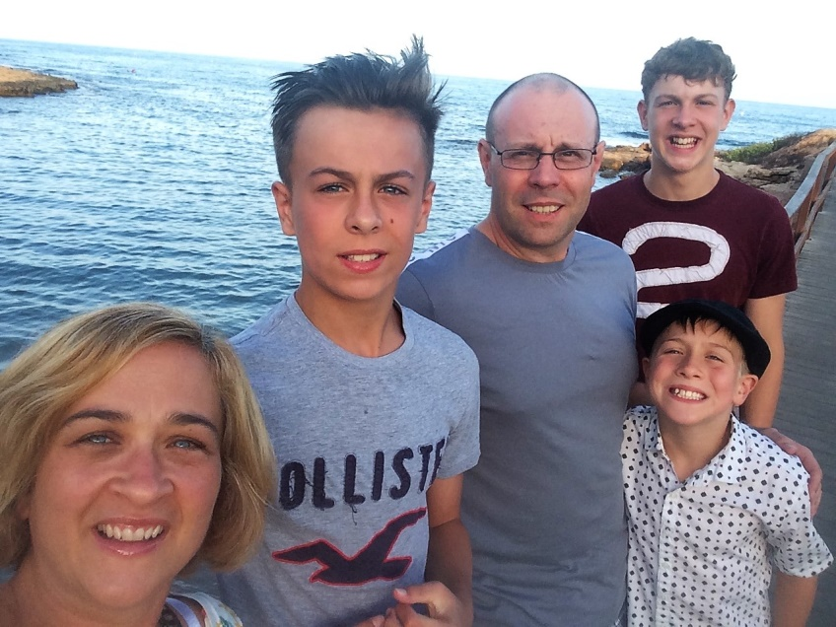

**Who lives in our house?**

We are Jared and Helen Hodgson. We have three boys – Toby, Max and Jonah.

**What’s our house like?**

Our house has six bedrooms, with the two spare rooms being on the top floor away from the other bedrooms. We have a shared bathroom, two living rooms, a dining room, kitchen and garden. We live in the middle of a town within walking distance to the shops, the doctor’s surgeries, local hospital, job centre and a beautiful local park.

**What kind of food do we eat?**

We love cooking and food! We eat family meals together every evening and we’d love you to join us. We eat lots of pasta, pizza, stir fries and enjoy cooking and trying new foods.

**Do we have any pets?**

Yes, a dog called Raven – she is quite energetic!

**What fun stuff do we do?**

Our house is sometimes busy with three children and all their noise and activities. We enjoy walks in the countryside, family days out to new places, eating together, spending time with friends, health and fitness, playing games and watching movies. We are part of a church and on Sunday mornings we go to meet with our church.

**Have we hosted anyone before?**

Yes, we have! We love hosting people in our home. We enjoy learning about different cultures, trying new foods and laughing together as we learn each other’s languages! The people we’ve hosted before have sometimes joined in with our family activities and sometimes they have preferred not to. We are really flexible and want you to feel at home with us here. Our boys are polite with our guests and treat them with respect.

**Do we have any house rules?**

We really want you to feel welcomed and at home with us, but we do have some rules that we all need to stick to.

Please see the Guest Agreement for house rules and sign this if you are happy with these.

Once every two weeks we will have a chat to make sure you are happy with the way things are going in the home and whether you have any concerns or questions. We might need to come up with some different rules or you might need us to change something, so please be honest with us! We want to make this work for all of us.